PAVOL BODNAR
&
InterJAZZional Band

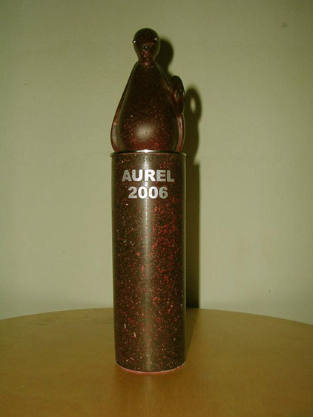

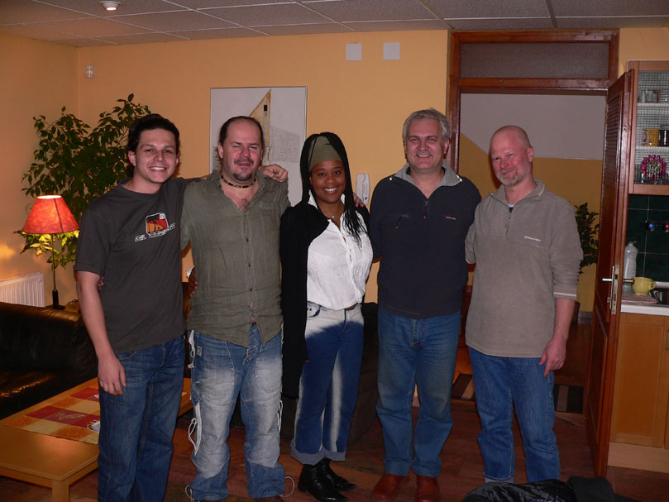

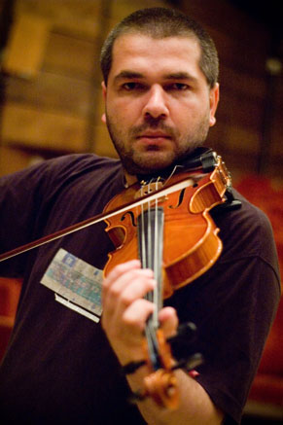
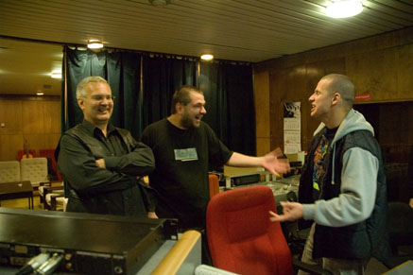
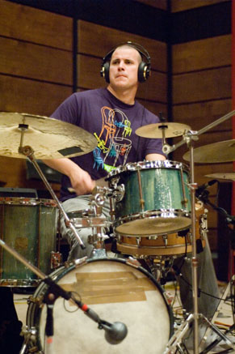
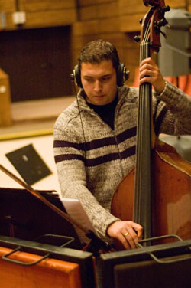

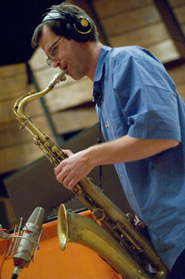

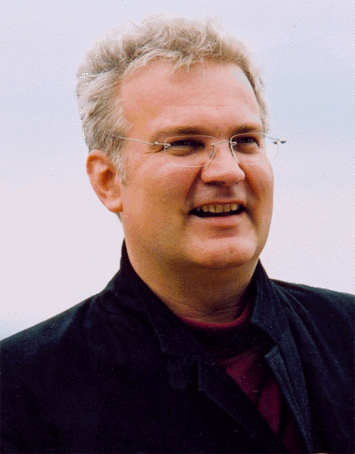
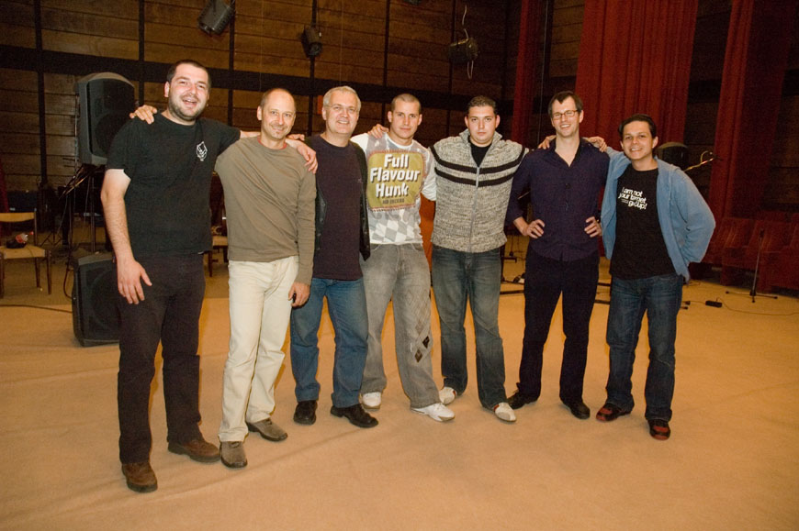

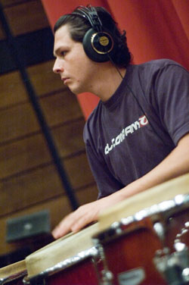

www.pavolbodnar.com
About the InterJAZZional Band
The group has been put together in order to play jazz, inspired by Slovak folk musik, Latin rhythms and European contemporary trends. The headmaster of this musical concept, Pavol Bodnar, is a jazz pianist, arranger and composer. The number of group members vary from (4) - quartet to (8) - octet.
A special, international sound is provided by its international membership that counts top jazz musicians from Central Europe and Cuba.
Slovak flavour is brought in by



Pavol Bodnar
Jazz pianist, composer
arranger and improvizer
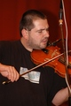
Stano Palúch
A unique violin improvizer
in term of folk and jazz

Jazz feeling is delivered by
everyone, but especially by
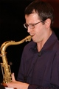

Borys Janczarski
An outstanding mainstream saxophonist
the representative of Polish jazz tradition
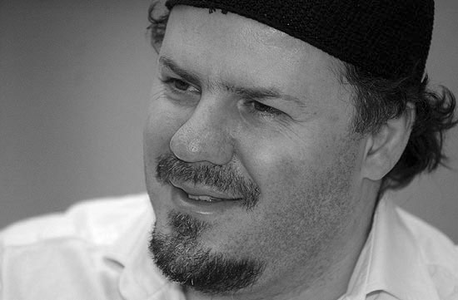

Winand Gábor
A phenomenal Hungarian singer

Latin-American drive is supplied by

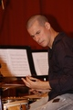
Martin Valihora
A fabulous and grounded drummer
member of famous Hiromi Uehara Trio



Eddy Portella
Down-to-earth percussionist
Peruvian Indian with Slovak blood


Elsa Valle
A vigorous Cuban singer
Latino diva living in Budapest
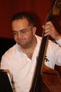

Tomáš Baroš
A top double-basist
From the Dremland of Jazz Basists, Prague

www.pavolbodnar.com

ECCE JAZZ
PAVOL BODNAR & InterJAZZional Band
A new album of a jazz pianist, composer and arranger, awarded
AUREL 2006/ Slovak GRAMMY
Best release in category of jazz/blues
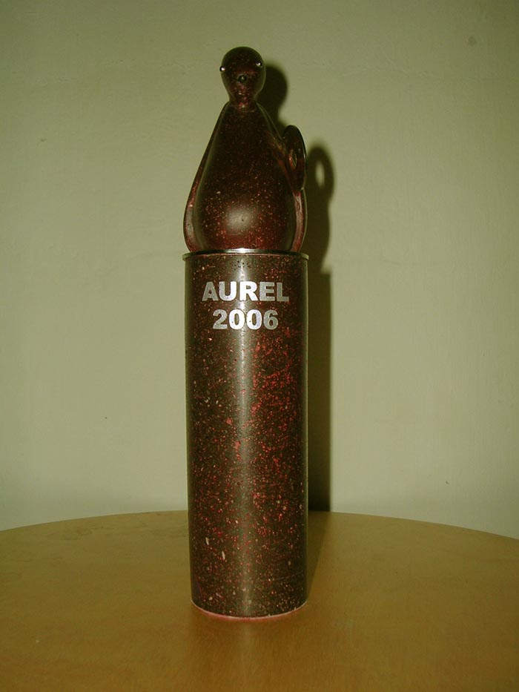
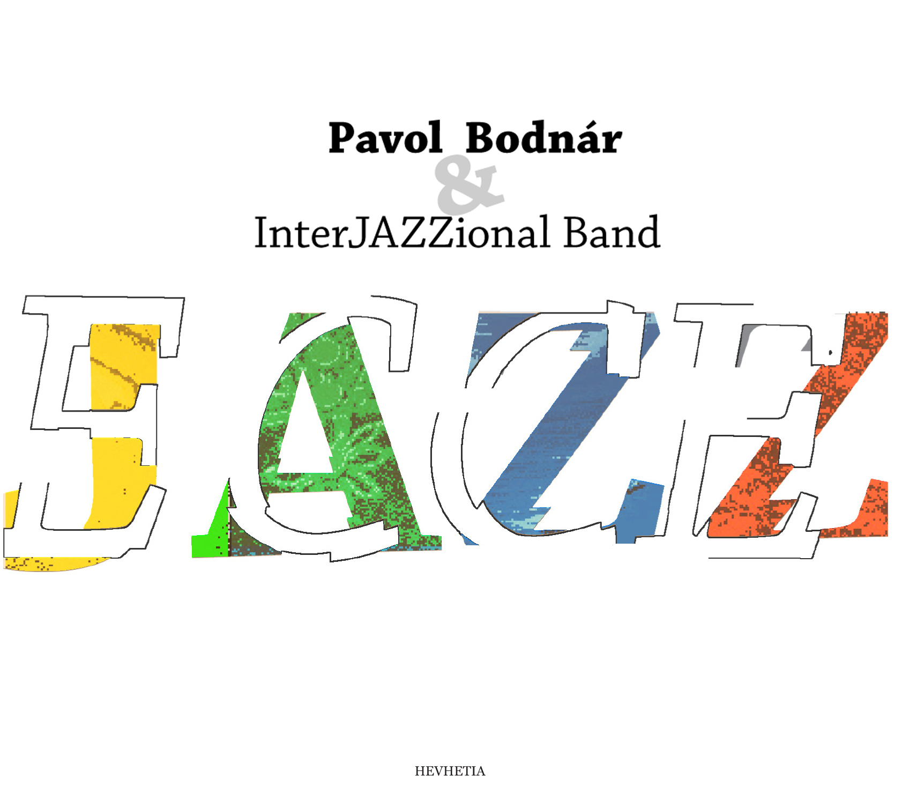

Ecce Jazz numbers twelve compositions that are addressed to jazz fans as well as to everyone who loves beautiful, enjoyable, colorful and yet highly original music. Ecce Jazz CD is on sale in USA, too, and its compositions have been succesfully airplayed from selected American radio stations for already five months.
The overall sound had been accomplished with the use of:
Slovak folk music motives
Variety of Latin-American rhythms
Contemporary European music trends
Heart of composer and art of all performing musicians

Ecce Jazz program
* Peacock Girl I * Peacock Girl II * Twelve Passions *
* Some Other Indiana * Peacock Girl III * 3 Roses 4 Martina *
* The Water Song * Chromatic Adventure * A Deep Brook *
* Marieli Lullaby * Puerto Rico I * Puerto Rico II *

www.pavolbodnar.com

Quotations from reviews

Although it´s only beginning of February, we self-confidently can say that the Ecce Jazz CD by jazz pianist and composer Pavol Bodnar will be among best jazz releases of this year.
Marián Jaslovský, SME, 01.03.2007

In my opinion, the way Bodnar handles Slovak themes in his „jazzy“ interpretation, has contributed to the fact that this apt, vivid and pulsing record can potentially become the happening of the season.
Rado Tihlárik, www.skjazz.sk Jazzovinky

This album is a must for the serious jazz connoisseur, but can also be enjoyed by the person that simply enjoys beautiful music created with passion.
Mike Matheny, Jazz Programmer´s List, vol 9, issue 164, 22.05.2007

Ecce Jazz CD definitely ranks very high in our book as one of the most sensual, and harmoneous projects to have been released in a long time...
James Groov, RadioIndy, 25.05.2007 ( Phoenix, Arizona )

He wrote tunes that you can keep listening to over and over. They present sparkling musical ideas, speak about musical history and education in music, they pulse at magic rhythms, hold one´s breathe...
Fellegi, Pravda, 24.02.2007

The album brings diverse set of compositions, distinctly original, which deliver a new sound to modern jazz... it is a sound which satisfies the desire for that something new often sought out by the sophisticated jazz listener.
Mike Matheny, Jazz Programmer´s List, vol 9, issue 164, 22.05.2007

The music on this CD clearly reflects an international sound like no other CD that we've heard recently.
James Groov, RadioIndy, 25.05.2007 ( Phoenix, Arizona )

The variety and sense of style, those are two attributes that correlate with each other in the same manner as the regard to tradition and the modern acoustic groove. Album represents top level, not only in Europe.
Marián Jaslovský, SME, 01.03.2007

www.pavolbodnar.com

Pavol Bodnar -Biography

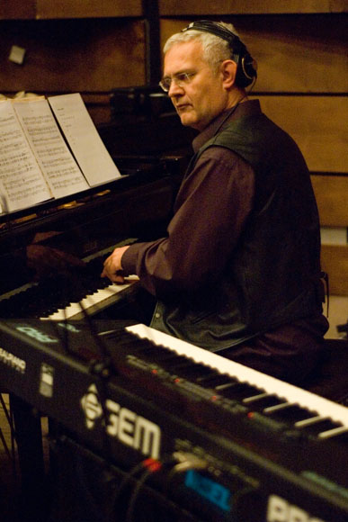
Pavol Bodnar is a jazz pianist, composer, arranger and teacher. In 1996, the Slovak Jazz Association awarded him the Ladislav Martoník Prize and the title Jazzman of the Year 1996 in Slovakia.
In addition to his study of European classical music at the Conservatory in Zilina ( 1976 – 1979 ) and biochemistry at J.A.Komensky University ( 1979 – 1984 ), he later attended prestigious Berklee College of Music for his jazz studies in Boston, Massachusetts, USA ( 1992 – 1993 ).
In 1990, Pavol was a finalist at the international jazz competition Concours Internationale des Thémes de Jazz in Monaco with his composition Cheerful Afternoon. This success resulted in his winning a full scholarship for the study at Berklee College.
As a pianist, arranger and composer, he has been working over the years with outstanding musicians of diverse styles, such as Joe Muranyi, Harry Sokal, Larry Smith, Winand Gabor, Peter Cardarelli, Piotr Baron, Grzegorz Nagorski, Elsa Valle, Márkus Tibor, Errol Weiss Schlabach, Barbara Montgomery, Enzo Ruggieri, Philippe Lavoipierre, Peter Lipa, Jaroslav Country Červenka, as well as with groups - Peter Lipa Band, Peter Cardarelli & Pavol Bodnár Band, Slovak Polish Jazz Quartet, Close Harmony Friends, Polemic, VladoVizar Jazz Quartet, All Time Jazz Trio.
Nowadays, he works mainly with two bands, the InterJAZZional Band and V4JAZZ. Recently, Bodnar began experimenting with use of Central European folk motives in jazz. His compositions reflect diverse influences he soaked up from the childhood, such as Slavic melodic, Latin rhythms, jazz harmonies and methods of contemporary European music.
His latest release - CD Ecce Jazz – ( Hevhetia, 2006 ) has been highly favoured and praised by journalists from Slovakia, Czech and USA as well as by listeners of concerned American radio stations. Ecce Jazz CD has been reviewed in both Slovakia and USA. The critics are very positive.
In 2000, Bodnar was the headmaster of the J.S.Bach anniversary concert Bach In Jazz & Jazz in Bach, that took place in Slovak Radio, Bratislava. In total, he has been involved in recording and production of some 25 CDs. Nowadays, Bodnar also teaches both the jazz and improvization at the Conservatory of Music in Bratislava.
www.pavolbodnar.com

Links to useful web sites

- www.pavolbodnar.com official web site
- www.radioiojazz.com review
- www.myspace.com/pavolbodnar unofficial web site
- www.cdbaby.com/cd/pavolbodnar CD sale in USA
- www.noisehead.com the music internet community
- www.radioindy.com/bands/2752/ unofficial web site
review

Noisehead Internet Community feed-backs

Your group is .. by far.. my favorite band at Noisehead.. your music is the star.. a guiding light.. bright size life.. RAPSTER

Thank you for this songs, this solos, this band. Stano Paluch! what a good sound ! and Borys! and Eddy Portella, Martin, you, ... Stefan, ... Elsa Valle and Gabor... all sounds incredible, well ensembled, ...
When in Barcelona?????
nice to meet you!!!!!! MUTZICK NAGUIM

This is a damn good band. Every track is such a joy. On this one, Ornette Coleman meets Django Reinhardt someplace in the middle. VINEJOCKEY

a real pleasure indeed to hear your absolutely top level jazz.. noisehead is hopefully delighted and honored to have you here.. cheers.. RAPSTER

Contact

Pavol Bodnar
Heydukova 18
811 08 Bratislava
Slovakia
EUROPE

Tel: 00421-908-78 33 88
Em: pavolbodnar@gmail.com

www.pavolbodnar.com

